Medieval Escape

Games Design Project

By Martin Harvey, David Irvine and David Turner-Willock

**Outline of the game idea (game overview, summary, justification of game concept and theme)**

Medieval Escape is a 2D puzzle game where the player must complete one of the assigned tasks within the given time limit. Each of the puzzles are all played on a single screen and are all focused on the gameplay of having everything already laid out and figuring out how to move around the environment to obtain the goal at hand. These goals can be, saving the princess (Create an exit for the princess), getting the gold (Moving the gold to the player) and defeating the monster (Killing the Monster using the environment).

Each of the puzzles within the game take inspiration from a series of advertisement that have been going about in the recently, the concept for the game is interesting but the games advertised are never the same as the game on the advertisement, so this is our take on the creation of the game within those adverts.

**Graphics (concept art sketches, storyboards, aesthetics, sprites, characters, asset lists)**

**Level Design overview: Use of Form, Space, Architecture, documented level design approach**

All of the levels designed are made to be played on one screen at a time.

**Mechanics and gameplay (procedures, rules of game, game flow, AI)**

The mechanics of the game are quite simple the player is able to manipulate beams and cut ropes, each of which serve a unique purpose.

The player will be able to traverse the level by moving left and right,

The beam acts as a floor or a wall depending on where it is places, by being able to slide the beams it allows the player to impact the environment around them using the water and gas that will be in the levels. The beams will only be able to be moved from a specific point on the beam that will be at one of the edges, this adds an element of difficulty by limiting what can be done and possibly blocking of easy solutions and forcing the player to think more thoroughly.

Ropes in the game will be anchored to two point in the map in a way that effect the player reaching their end goal, this could be holding a door shut, holding an object that could be used as a weapon or connecting to points that are needed to reach the goal but need to be cut to complete the level. The way the rope works is that it is connected to two locations, the player will be able to cut the rope which will have an effect on the environment it is attached too, depending on where on the rope it is cut can also affect how things react as the rope will be using physics to simulate real life.

Water will be a free-flowing liquid that will be used as a game mechanic to assist the player in traversing the game environment by affecting the level in a way that is beneficial to the player, the main function of the water in medieval escape is to diffuse the effects of the other element in the game, gas. Gas is going to work similarly to water, flowing freely and being affected by the environment around it, it is an obstacle to the player, killing the player when they come in contact with the gas. Water and Gas are a joint game mechanic with water counter the gas while gas counters the player adding some depth to the overall game.

**Flow charts representing game states or use of UML**

Main Menu Flowchart

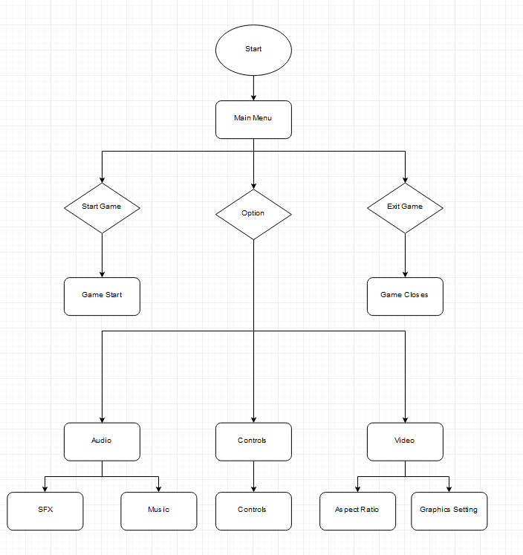

**Documented software development approach and testing methodologies (evidence of how used - GDLC)**

**Quality Assurance (fixing of bugs)**

**Production (assets and source code), documentation of coding practices and standards**

**Art and audio production (software used and sound clips)**

**User Interface, HUD, Game Maps**

The user interface for the game consist of a main menu, a menu that displays 3 Buttons, “Start Game” (begins the game), “Options” (Give the player option to change the volume of both the music and the sound effects within the game, the graphical setting of the game and the control scheme for the game.) and “Exit Game” (Closes the game).

Once in the game the player will be prompted with there objective on screen and have a heads up display on screen that will inform the player if they have collected or completed the objective that will allow the level to be completed.

The layout for each level will be contain within one static screen.

**Evidence of games immersion, cognitive flow and game balance**

**Documentation of playtesting (approaches adopted)**

**Evidence of Project Management (Tasks and development milestones)**

**Evidence of use of GitHub**